Exploring the Data Layer
Sub Title

Exploring the Data Layer 1
SQL Server Object Explorer 1
Creating a New Table 4
Implementing a Table Schema 5
Setting the Table Name 6
Creating the Primary Key 6
Setting the Rest of the Fields 8
Now the Important Bit! 8
Adding Data 9
Stored Procedures 11
Creating Stored a Procedure 12
Executing the Stored Procedure 16
Using the Data Connection 19
C# Code for Delete 19

Exploring the Data Layer
In this eLecture we will look at some of the tools available for you to use in Visual Studio that allow you to work with the data layer of your system.
Although your database will be hosted in MS Azure for the most part you will be creating tables and queries within the Visual Studio IDE, this is useful as it creates the same interface for modifying your database structure regardless of the database technology being used. You could in theory switch the database from Azure to MYSQL and Visual Studio would provide you with the same set of features.
Much of this work will involve an orientation exercise such that you know what components we are creating and why, also to give you an idea of what buttons to press to achieve the required outcome.
There are four components that we want to look at in these examples, they are…
- Tables and how to create them
- Adding data to tables
- Stored procedures and how to create them
- Executing stored procedures
- Using the DataConnection class
In this work we will not be looking at how to set up your account in Azure and connecting to Visual Studio as that will be covered in the lab work.

SQL Server Object Explorer
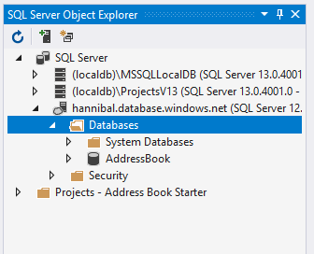
For the most part editing the database will be handled within the SQL Server Object Explorer Window in Visual Studio.
Assuming you have created your database using the on-line Azure Portal once connected you should see something like the image above.
To inspect and modify the structure of the database you need to expand the sections by clicking on the triangles like so…
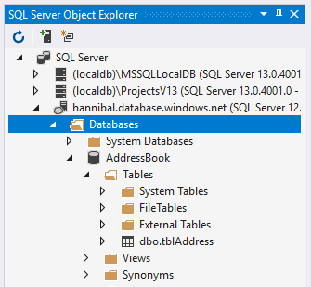
In this example we can see a table called tblAddress.
To inspect the structure of the table right click on it and select View Designer…
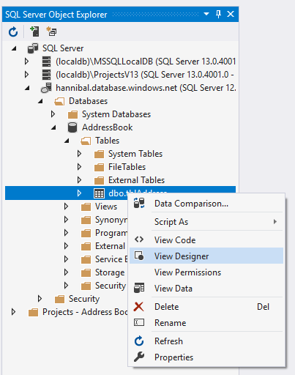
This allows you to inspect and modify the schema of the table…
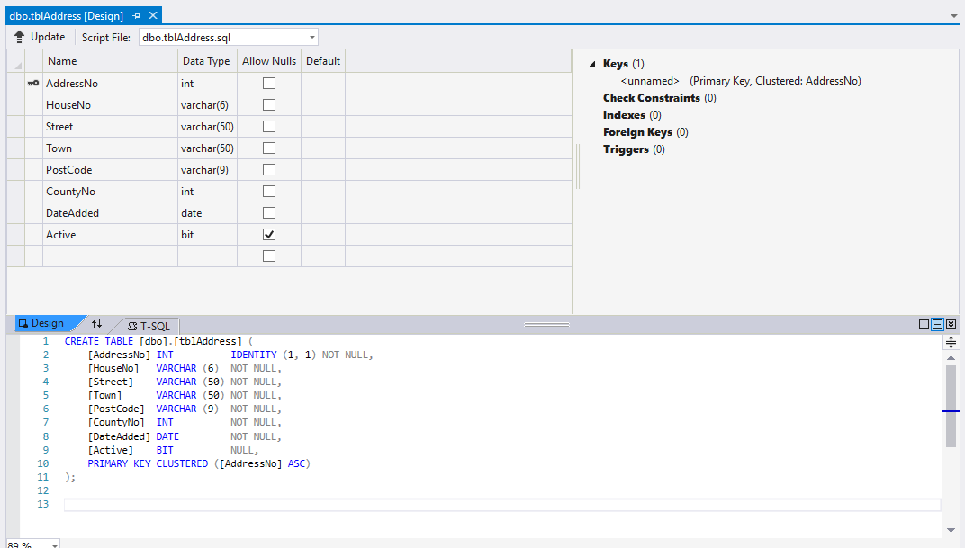

Creating a New Table
The procedure for creating a new table is very similar, right click on the tables section and select Add New Table…
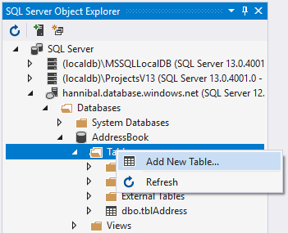
This will display the blank designer like so…
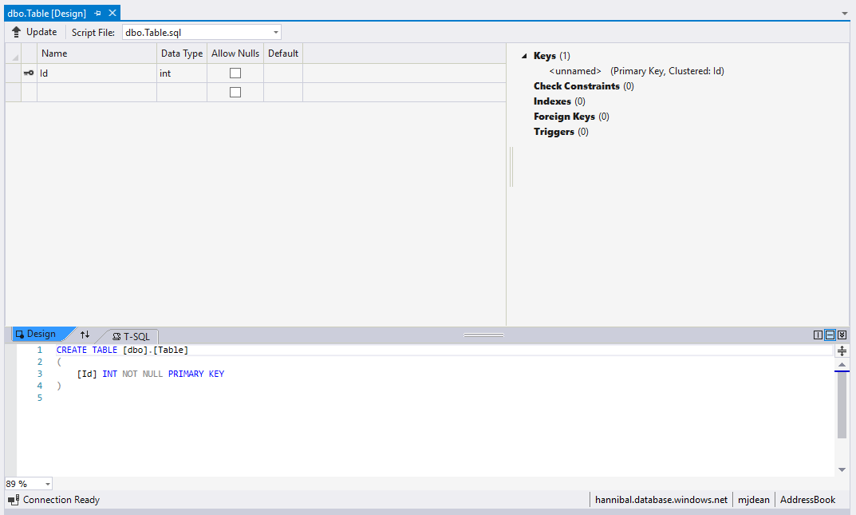

Implementing a Table Schema
Let’s have a go at creating a new table using the following schema…
tblWidget
WidgetID int Identity
WidgetName varchar(50)
DateAdded date
Active bit
Price money

Setting the Table Name
Notice the two sections in the above designer. The top section offers a more visual approach to creating the columns for the table. The section at the bottom allows you to write code that does exactly the same thing but you need to keep an eye on getting the syntax right.
To set the table name we shall edit the code directly like so…
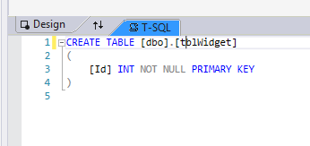
Once the name of the table has been set we may now use the top window to create the attributes for the table.

Creating the Primary Key
The primary key needs some additional consideration when compared to the other fields.
Firstly we want the value of the field to be unique, such that two records don’t end up with the same unique identifier. Secondly we want the value to be automatically generated by the database engine so we programmer doesn’t need to think about it ourselves. To achieve this we need to set the field up with “Identity” set to true.
First set the name of the field like so…
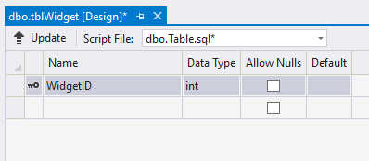
Now, in the bottom right hand corner of the IDE you should see the properties window…
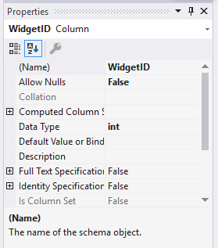
Expand the sction marked “Identity Specification”…
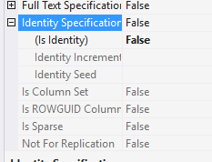
Flip “Is Identity” from False to True…
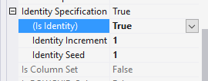
Notice the default settings for Increment and Seed. Seed is set to 1 so that the first record you create will be set to 1. Increment means that the next record you create will be 2. If you adjusted these settings you could start the primary key at 10 and have it increase in increments of 10 if you wished.

Setting the Rest of the Fields
Modify the table design to cover all of the attributes we need like so…
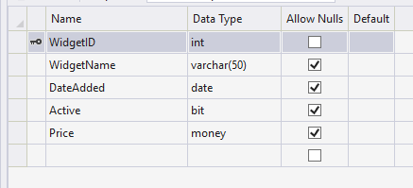

Now the Important Bit!
The logical thing to do at this stage is to press save, thus saving the scheme. Good idea but it won’t do what you think it does.
All save does is save the definition but it doesn’t modify the database.
To actually modify the database you need to press the button for “Update”.
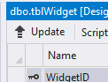
This should present you with the following reporting window which tells you if there are any problems with the design…
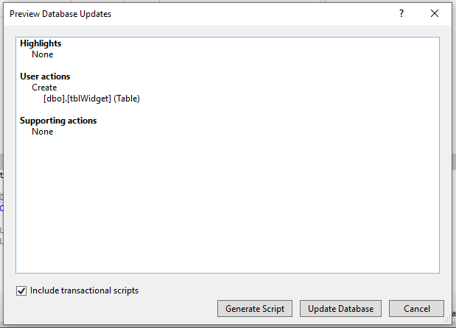
If there are no errors here, press the button for Update Database.
What you are looking for is a green tick telling you everything is OK…
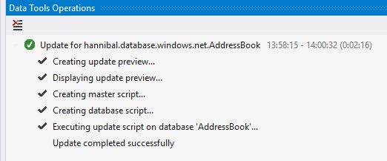

Adding Data
Once the table is created you will see it listed in the explorer window…
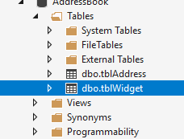
To add some data right click on the table and select View Data…
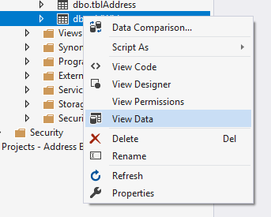
You should see a data entry window like so…
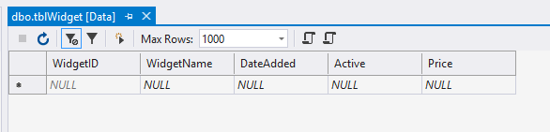
To add records, type into the blank fields marked NULL, note that the primary key WidgetID is read only so you can’t edit it.
Look at the following records noting how the primary key has been set automatically for you…
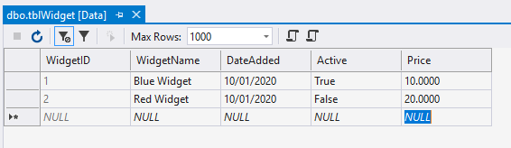
It is also worth pointing out the Price format too. Given that the data type money is able to hold a range of currencies the number of decimal places has been set to take account of this.

Stored Procedures
Stored procedures store and execute SQL that allows us to manipulate the data in the tables.
We have already seen in the last lecture that our system is to be split into layers like so…
Presentation
(Interface)
Data Layer
Database
Middle Layer
Business Logic
(Classes)
It is also often the case that these layers are also split into smaller layers, again following the policy of creating modular functionality.
In our case the data layer is to be split like so...

Middle Layer
Business Logic
Tables
Stored Procedures
Data Layer
In this design our middle layer code sends instructions to and receives data from the stored procedures, why?
Firstly there is an issue of security. The stored procedures act as an intermediary on the data in the tables which gives us more control as to how the data may be accessed.
Secondly there is an issue of code re-use. If there is a really useful section of SQL in our system then it makes sense to create this code only once and then use the stored procedure as and when needed.

Creating Stored a Procedure
The process for creating a stored procedure is very similar to creating a table.
From the explorer window expand the section for stored procedures like so...
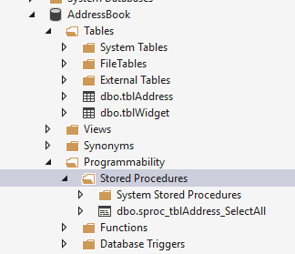
To create a new stored procedure right click on the text for Stored Procedure and select Add New Stored Procedure
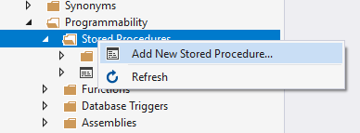
This will present you with the designer window like so...
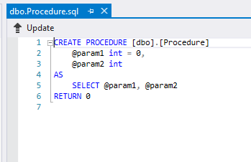
It is rather less visual than the one for creating tables but it will do the trick.
We will create a stored procedure that allows us to delete a record in tblWidget based on the value of a parameter we will provide as a primary key.
To give the stored procedure a name modify the top like so...
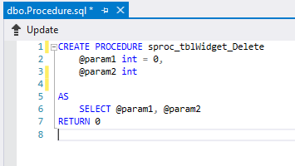
We are using the following naming convention.
sproc helps us see that this is a stored procedure i.e. not a table
tblWidget tells us which table it is acting on
Delete tells us what it is doing to the table
To create the parameter modify the SQL like so...
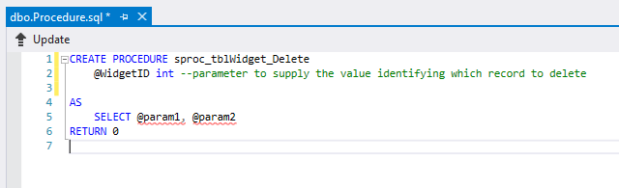
Lastly we want to create the SQL that will do the deleting...
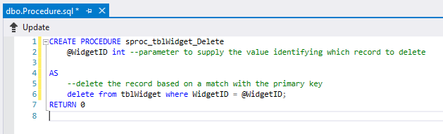
Note how the @ symbol differentiates the parameter @WidgetID from the field WidgetID!
To save the stored procedure you need to press the update button as before...
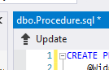
You will be presented with an error reporting window...
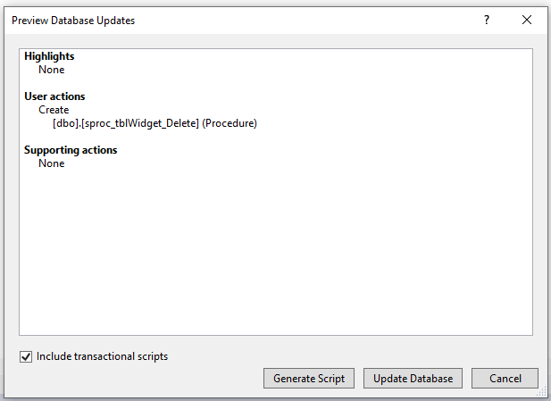
If all is well then press Update Database to modify the database structure.
As before you are waiting for the green tick...
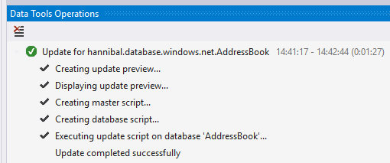
You should be able to see the stored procedure in the explorer window...
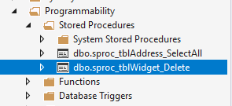

Executing the Stored Procedure
The process for executing the stored procedure is similar to the actions above.
Right click on the stored procedure and select Execute Procedure
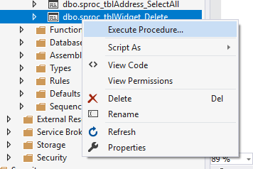
The first thing the stored procedure will need is a value for the parameter @WidgetID so that it knows which record to delete...
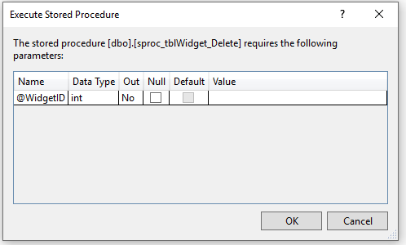
If this is the data in the table...
Let’s delete record 1...
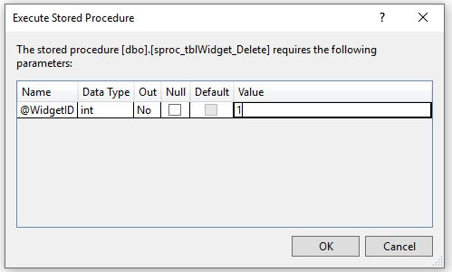
Press OK to execute the stored procedure. You will see a report indicating if all went well...
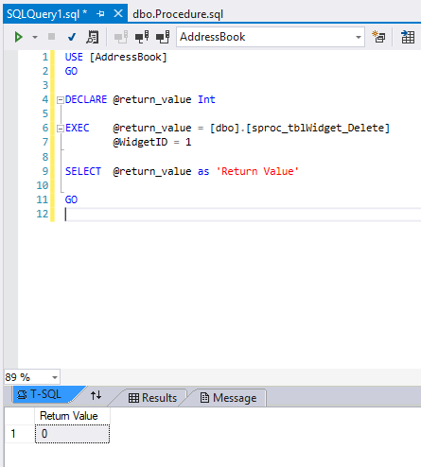
No errors so we are good to go.
Look at the data in the table to see if the delete has happened. If the record is still there press the refresh button...
The data should now look like this...
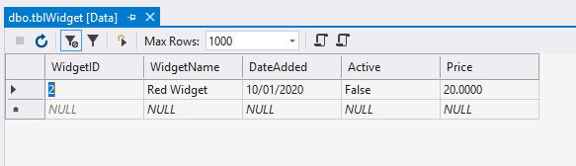

Using the Data Connection
If we look at the following diagram again we can see how the next stage of the functionality needs to operate.

Middle Layer
Business Logic
Tables
Stored Procedures
Data Layer
We have implemented both are table and stored procedure but we now need some mechanism for the middle layer classes to send instructions to the stored procedure. This is where the data connection comes in.
The data connection class has been written specifically to allow your middle layer classes communicate with the data layer.
We won’t look in too much detail at the configuration of the class as we will do this in the lab notes.
We will look at an example in C# that replicates the same sequence of actions we carried out above working directly with the stored procedure.
In the example above we activated the stored procedure, sent some data to the parameter and then ran the SQL.

C# Code for Delete
The following function in C# carries out the same action as the above
